Entering License Key for Visual Studios Professional 2017

1. Install all require components that you will need, then restart your machine.

Navigate to Help > Register Product.

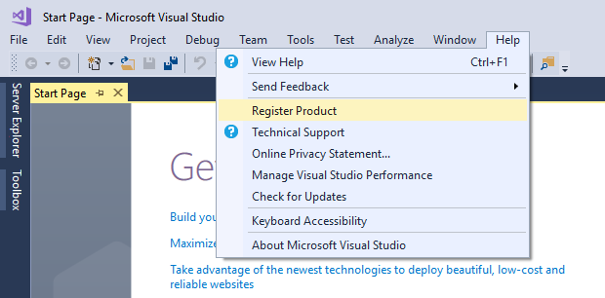

1. Select Unlock with a Product Key

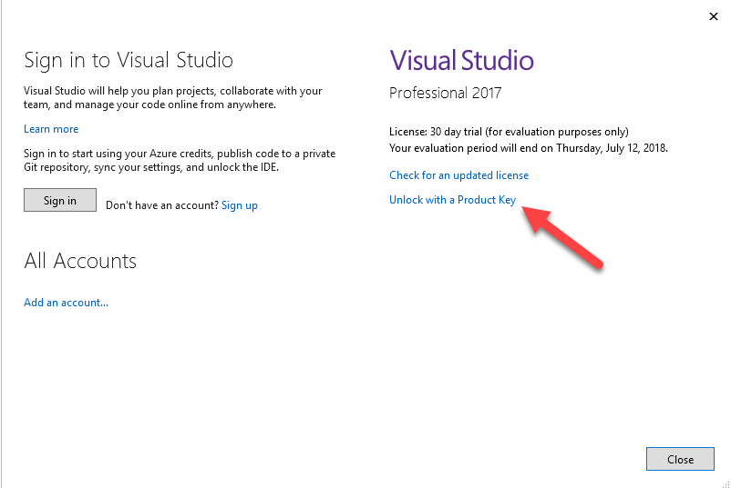

1. Enter product key provided in the Visual Studio Professional 2017.txt file in the following box.

